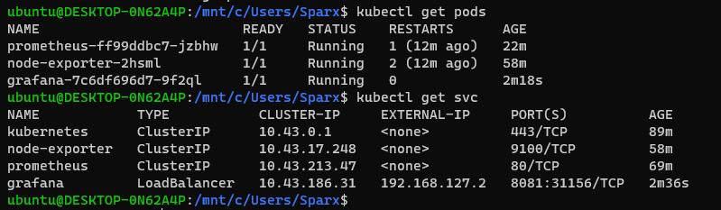

Configuration of node-exporter metrics for Prometheus and grafana for linux system monitoring.

Successfully configured node-exporter in Prometheus with adding scrape job in config file of prometheus

Graph for Prometheus with parameter gc duration cpu time 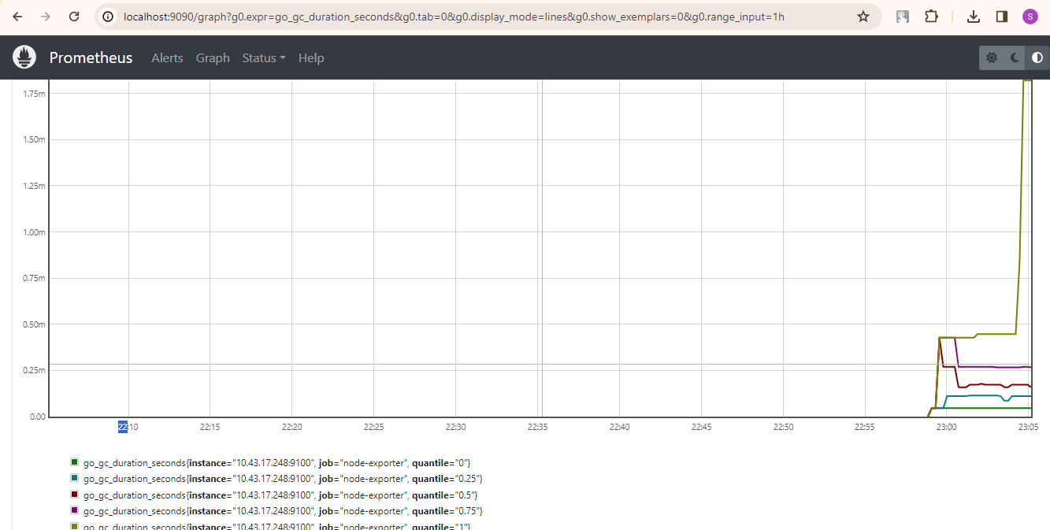

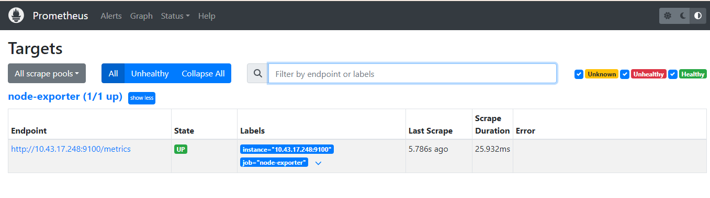



Configured Prometheus server for monitoring with url

Create one query and run

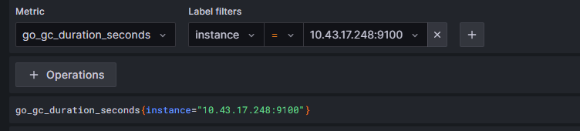

output

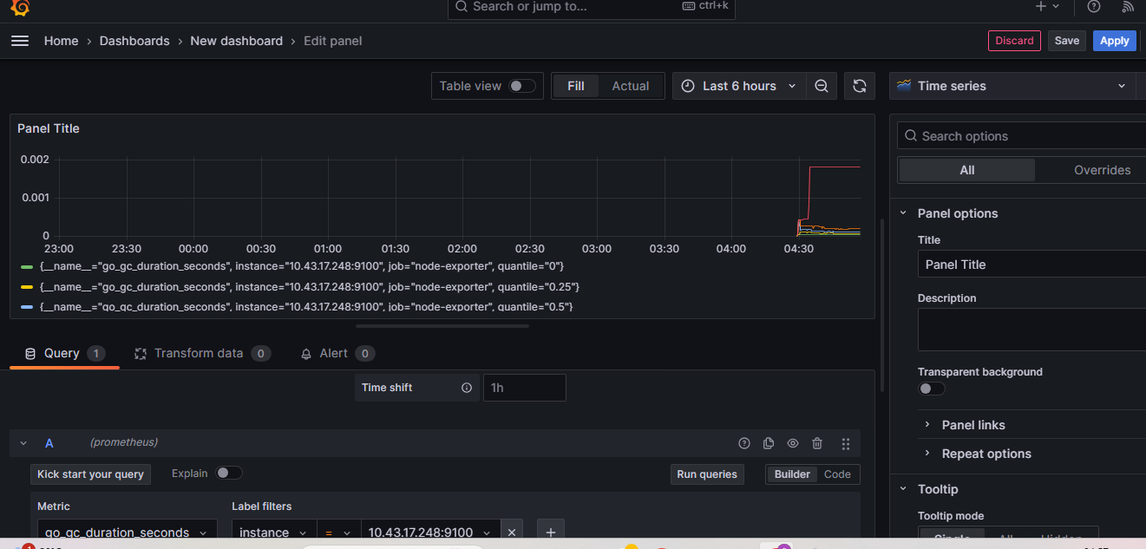

Final configuration in grafana:

